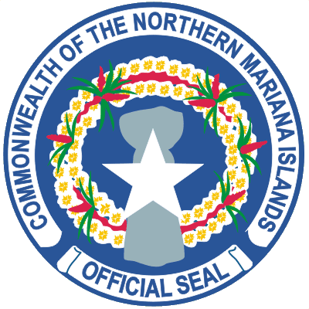
COMMONWEALTH OF THE NORTHERN MARIANA ISLANDS
OFFICE OF THE MAYOR
THE HONORABLE EFRAIM M. ATALIG
Mayor of the Municipality of Rota

Mailing Address: Post Office Box 537 Rota, MP 96951
Phone: 670.532.9451/9452 * Fax No.: 670.532.9454 * Email: mayorefraimatalig@gmail.com

September 7, 2016

Hafa Adai,

The Honorable Efraim M. Atalig, Mayor of Rota, cordially invites you to attend our "2nd Rota Coconut Festival" festivities that will take place on September 26 to September 30, 2016. Attached you will find our flyer ad that lists our daily activities with specific time and location.

If you have any questions or would like to RSVP, please contact Aubry Hocog at 670-532-9451/671-777-5570 or email her at aubryhocog@gmail.com.

